THEORY OF COMPUTATION

WITH

CONTEXT FREE LANGUAGE

DATE:03/05/23

NAME: ANTO FELIX

REG NO: 192111089

COURSE CODE: CSA1371

1] Design DFA to accept bcaaaaaaaaaaaaaa, bc, and c

AIM: To Design DFA to accept bcaaaaaaaaaaaaaa, bc, and c

PROCEDURE:

1. We check the automata needed and we select the required.
2. We now add the states as per our needs (initial, final).
3. We now add the transitions to the states as per our needs.
4. We can now name the transition as well as the states by right clicking on them.
5. We can now run the automata using the given input and observe for any corrections.
6. Once we complete with the design now we can record the in output.

DESIGN: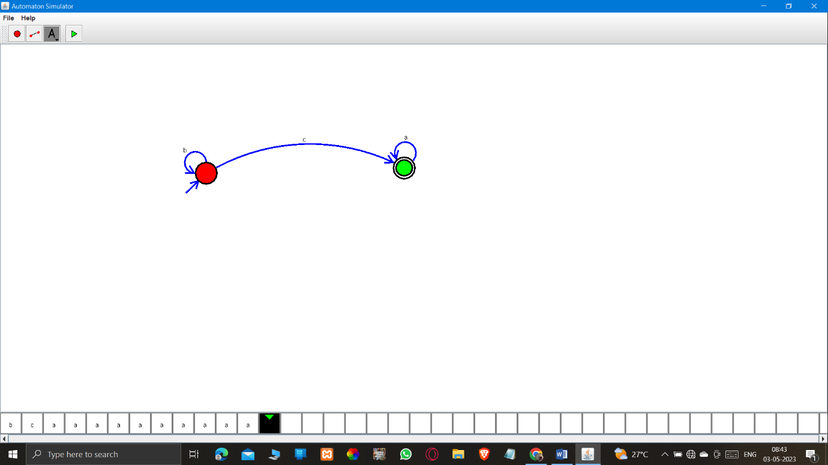

RESULT: Hence the design was Successfully executed.

2] Design NFA to accept aaaaaa

AIM: To Design NFA to accept aaaaaa

PROCEDURE:

i) We check the automata needed and we select the required.

ii) We now add the states as per our needs (initial, final).

iii) We now add the transitions to the states as per our needs.

iv) We can now name the transition as well as the states by right clicking on them.

v) We can now run the automata using the given input and observe for any corrections.

vi) Once we complete with the design now we can record the in output.

DESIGN: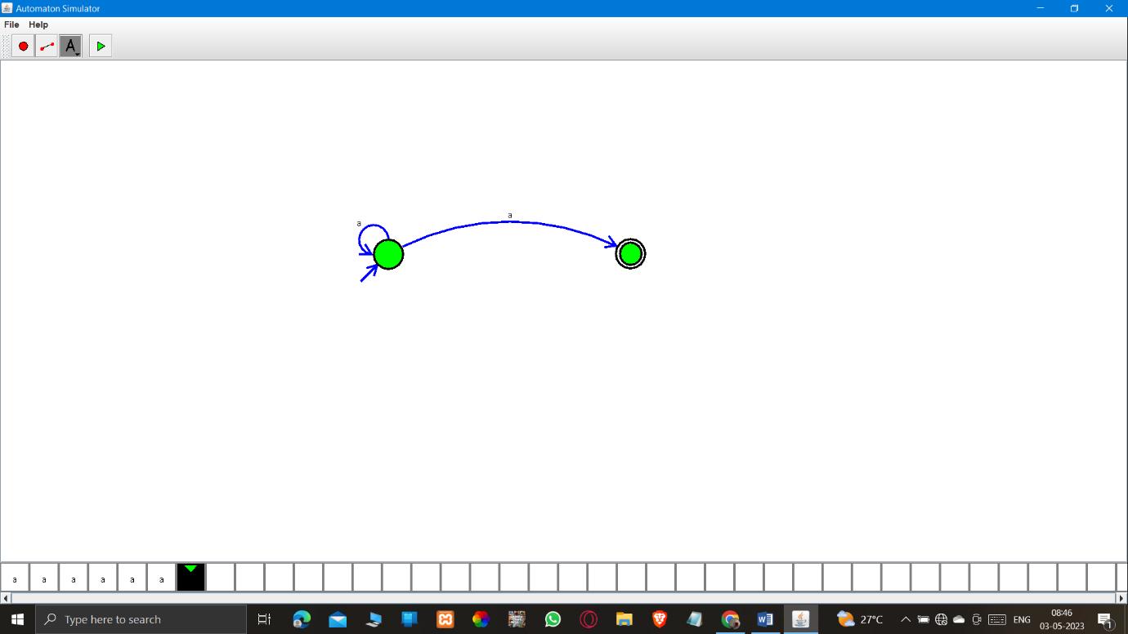

RESULT: Hence the design was Successfully executed.

3] Design PDA for the input a^nb^n

AIM: To Design PDA for the input a^nb^n

PROCEDURE:

i) We check the automata needed and we select the required.

ii) We now add the states as per our needs (initial, final).

iii) We now add the transitions to the states as per our needs.

iv) We can now name the transition as well as the states by right clicking on them.

v) We can now run the automata using the given input and observe for any corrections.

vi) Once we complete with the design now we can record the in output.

DESIGN: 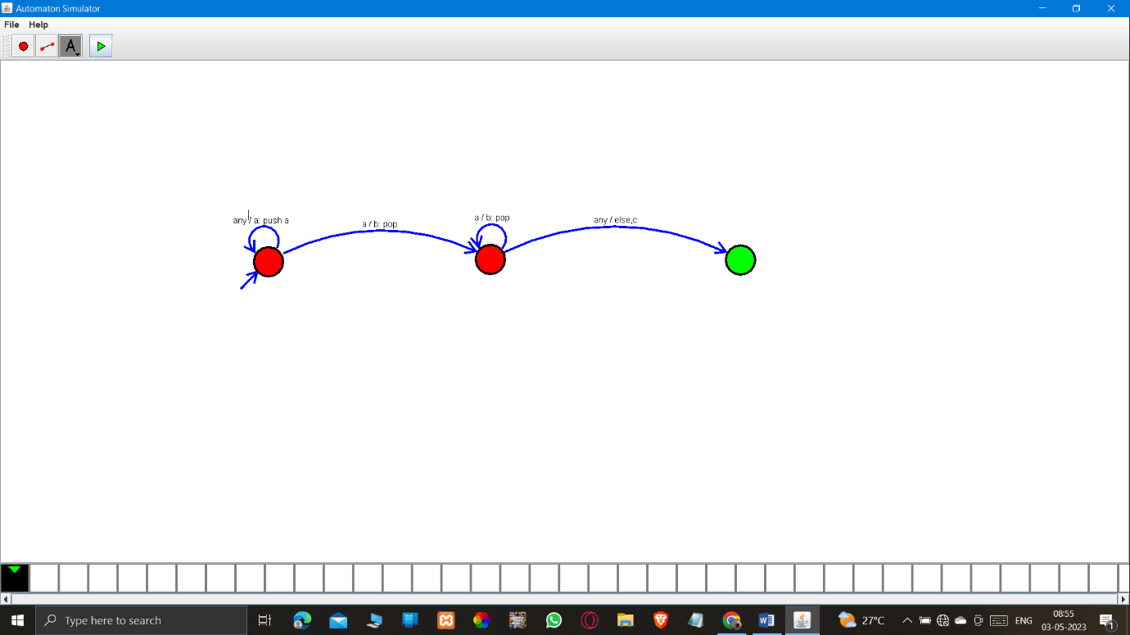

RESULT: Hence the design was Successfully executed.

4] Design TM for input a^nb^n

AIM: To Design TM for input a^nb^n

PROCEDURE:

i) We check the automata needed and we select the required.

ii) We now add the states as per our needs (initial, final).

iii) We now add the transitions to the states as per our needs.

iv) We can now name the transition as well as the states by right clicking on them.

v) We can now run the automata using the given input and observe for any corrections.

vi) Once we complete with the design now we can record the in output.

DESIGN:

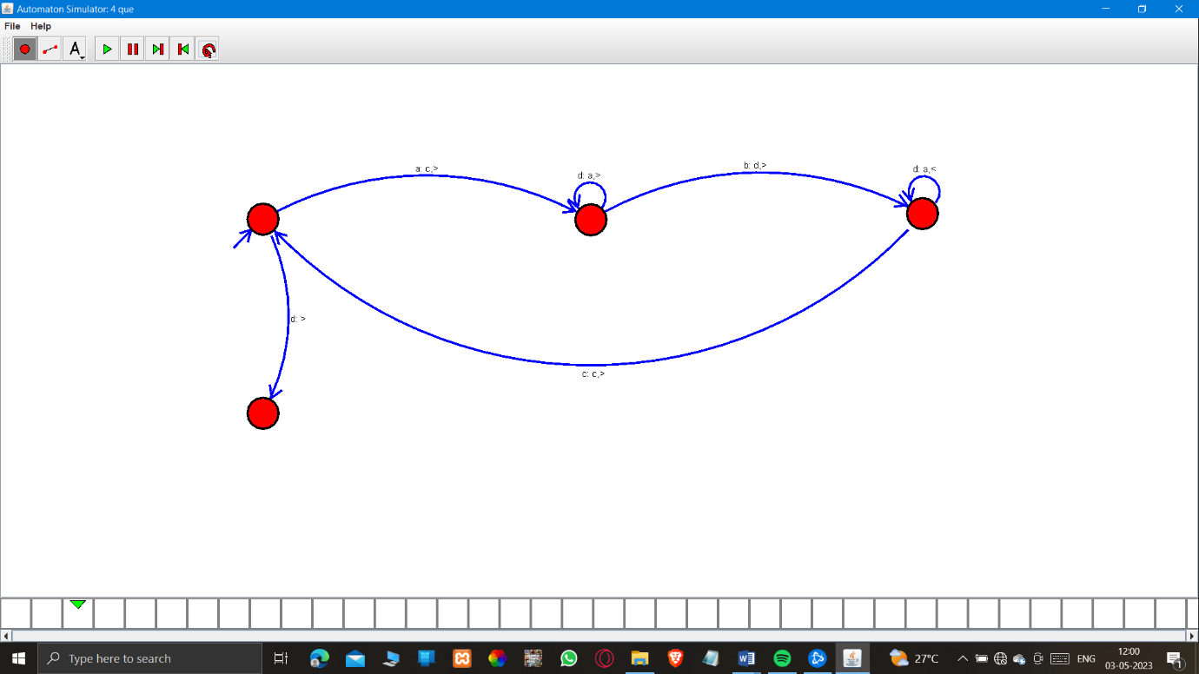

RESULT: Hence the design was Successfully executed.

5] Design PDA for input aabbbbc (L=a^nb^2n)

AIM: To Design PDA for input aabbbbc (L=a^nb^2n)

PROCEDURE:

i) We check the automata needed and we select the required.

ii) We now add the states as per our needs (initial, final).

iii) We now add the transitions to the states as per our needs.

iv) We can now name the transition as well as the states by right clicking on them.

v) We can now run the automata using the given input and observe for any corrections.

vi) Once we complete with the design now we can record the in output.

DESIGN: 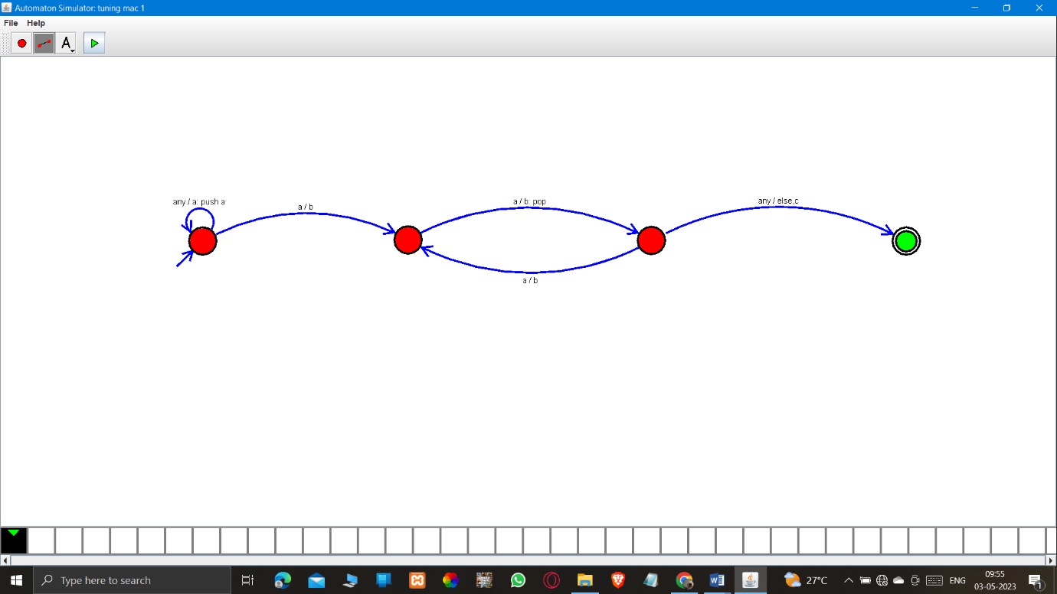

RESULT: Hence the design was Successfully executed.

6] TM Simulation for Palindrome W= ababa c

AIM: To TM Simulation for Palindrome W= ababa c

PROCEDURE:

i) We check the automata needed and we select the required.

ii) We now add the states as per our needs (initial, final).

iii) We now add the transitions to the states as per our needs.

iv) We can now name the transition as well as the states by right clicking on them.

v) We can now run the automata using the given input and observe for any corrections.

vi) Once we complete with the design now we can record the in output.

DESIGN: 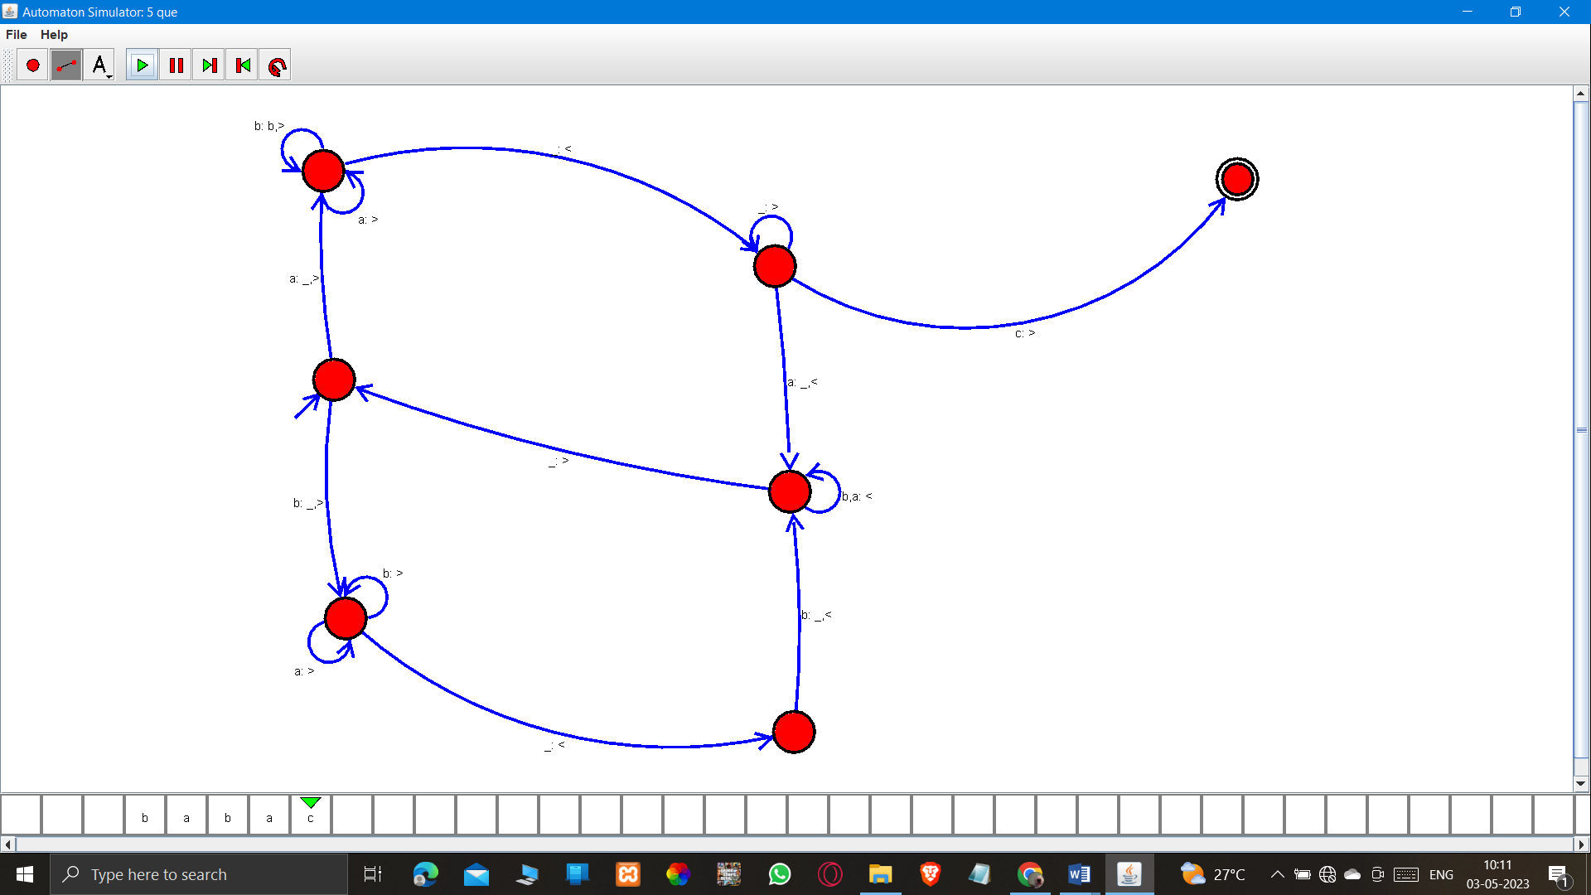

RESULT: Hence the design was Successfully executed.

7] Design TM to perform addition of following

W= aa + aaaa

After Addition of a’s = aaaaaa

AIM: To Design TM to perform addition of following

W= aa + aaaa

After Addition of a’s = aaaaaa

PROCEDURE:

i) We check the automata needed and we select the required.

ii) We now add the states as per our needs (initial, final).

iii) We now add the transitions to the states as per our needs.

iv) We can now name the transition as well as the states by right clicking on them.

v) We can now run the automata using the given input and observe for any corrections.

vi) Once we complete with the design now we can record the in output.

DESIGN: 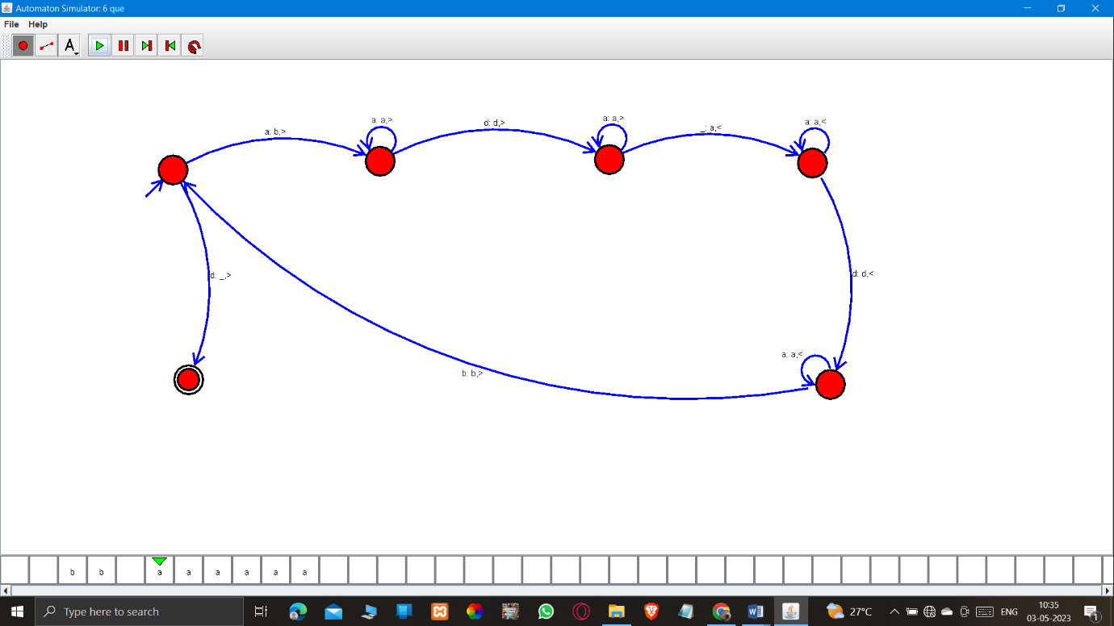

RESULT: Hence the design was Successfully executed.

8] Design TM to perform subtraction

W= aaa-aa

The Result of Subtraction is = a

AIM: To Design TM to perform subtraction

W= aaa-aa

The Result of Subtraction is = a

PROCEDURE:

i) We check the automata needed and we select the required.

ii) We now add the states as per our needs (initial, final).

iii) We now add the transitions to the states as per our needs.

iv) We can now name the transition as well as the states by right clicking on them.

v) We can now run the automata using the given input and observe for any corrections.

vi) Once we complete with the design now we can record the in output.

DESIGN: 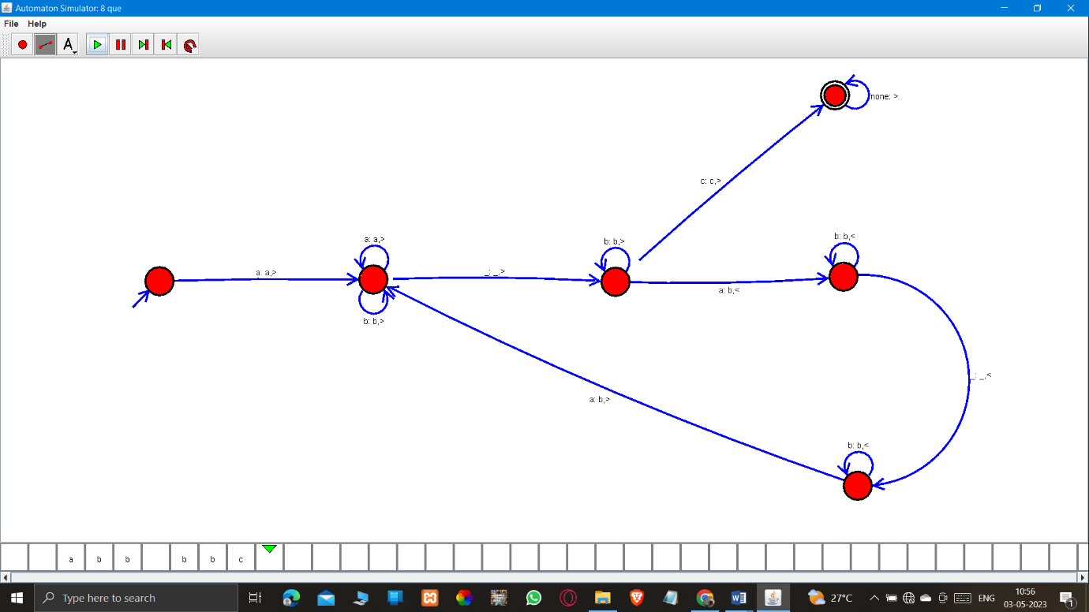

RESULT: Hence the design was Successfully executed.

9] Design TM to perform string comparison

W = aba aba

AIM: To Design TM to perform string comparison

W = aba aba

PROCEDURE:

i) We check the automata needed and we select the required.

ii) We now add the states as per our needs (initial, final).

iii) We now add the transitions to the states as per our needs.

iv) We can now name the transition as well as the states by right clicking on them.

v) We can now run the automata using the given input and observe for any corrections.

vi) Once we complete with the design now we can record the in output.

DESIGN:

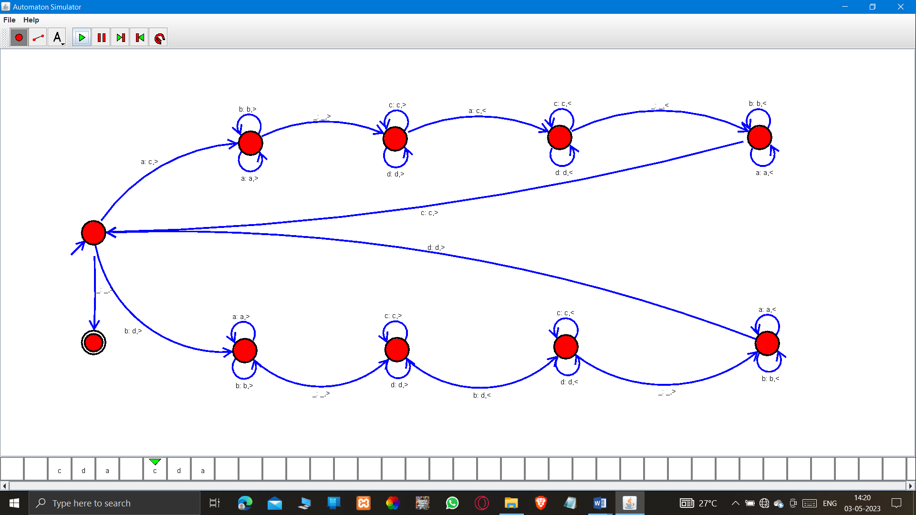

RESULT: Hence the design was Successfully executed.